## Project Idea 3: Remote Desktop App based on FreeRDP (using GUI similar to Microsoft RDP)

Group:

Cornelius (Niall) Broderick 9119124

Deirdre Shanahan 16230256

## Connect to your PC with an Android device

Step 1: Make sure when you launch the RD client, that you're on the Remote Desktops tab. From there, tap on the "+" to add a new connection.

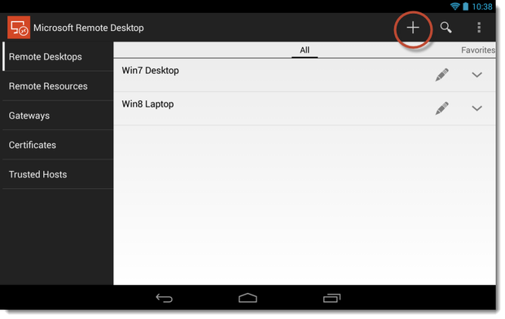

Step 2: Enter a name for the connection, the host name or IP address of the remote PC, and the log-in credentials if you want them saved. If you leave the credentials blank, you'll be prompted for them at the start of the connection. Tap "Done" to save the remote desktop connection.

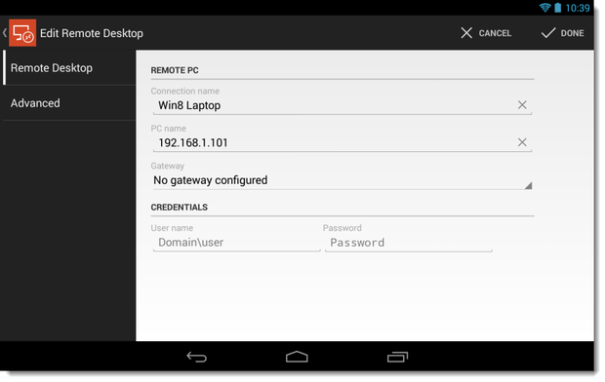

Step 3: Tap on the connection you just created to connect. If you get an untrusted certificate prompt, select "Trust Once" or "Trust Always," if you trust the remote PC. You should then see your remote PC's desktop.

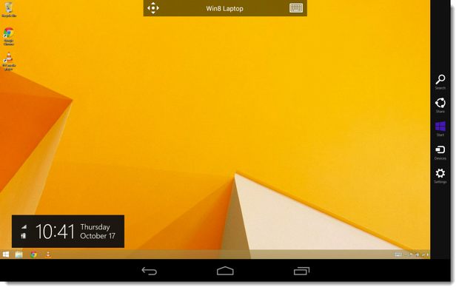

## Navigating the remote connection

The connection bar at the top has two icons: the pan icon on the left and the keyboard icon on the right. Tap on the pan icon to zoom in on the desktop and move around. The keyboard icon displays or hides an onscreen keyboard. If the connection bar is in your way, you can long press on it, then move it from side to side.

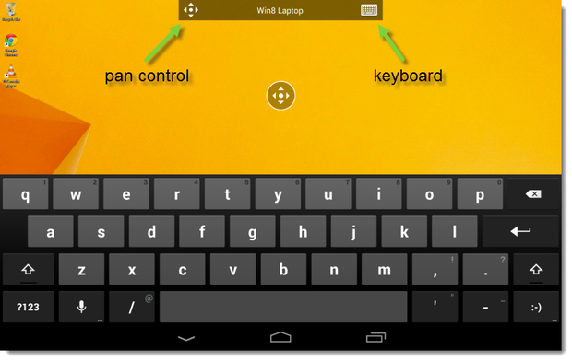

Tapping on the connection bar will bring up the utility bar. With the utility bar, you can disable multitouch and use a cursor instead, display modifier keys for shortcuts, and access many extra keyboard keys, like the F-keys. Hint: double-tapping on the Windows key will toggle between the desktop and the Start screen in Windows 8.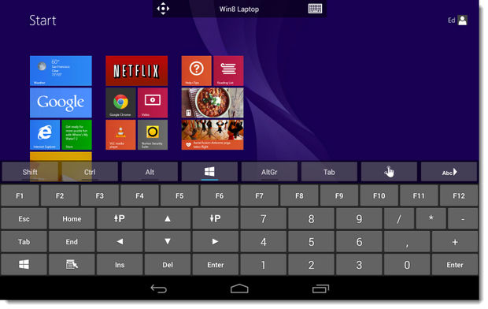

To disconnect from the remote PC, tap the back button of your Android device twice. Also, if there are remote PCs that you frequently connect to, you can create direct shortcuts to them using the Remote Desktop widget.